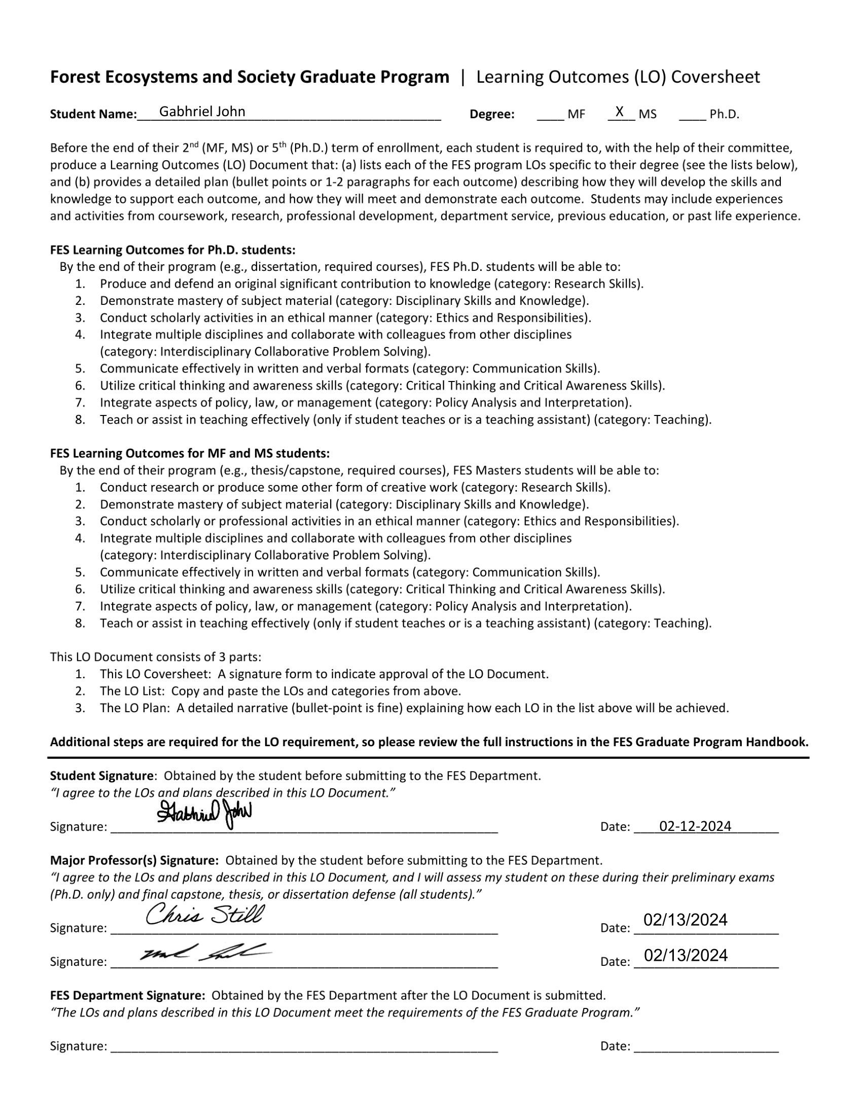

**GABBY JOHN**

OREGON STATE UNIVERSITY COLLEGE OF FORESTRY

MASTER OF SCIENCE IN FOREST ECOSYSTEMS AND SOCIETY

**LEARNING OUTCOMES**

**List of FES Learning Outcomes for MS students to be completed by the end of the program (from** [**FES’s instructions**](https://fes.forestry.oregonstate.edu/sites/default/files/fes/LO_Instructions_2023.pdf)**):**

1. Conduct research or produce some other form of creative work (category: Research Skills).
2. Demonstrate mastery of subject material (category: Disciplinary Skills and Knowledge).
3. Conduct scholarly or professional activities in an ethical manner (category: Ethics and Responsibilities).
4. Integrate multiple disciplines and collaborate with colleagues from other disciplines (category: Interdisciplinary Collaborative Problem Solving).
5. Communicate effectively in written and verbal formats (category: Communication Skills).
6. Utilize critical thinking and awareness skills (category: Critical Thinking and Critical Awareness Skills).
7. Integrate aspects of policy, law, or management (category: Policy Analysis and Interpretation).
8. Teach or assist in teaching effectively (only if student teaches or is a teaching assistant) (category: Teaching).

**Gabby’s specific plan to achieve all 8 Learning Outcomes (LOs) above:**

From [FES’s instructions](https://fes.forestry.oregonstate.edu/sites/default/files/fes/LO_Instructions_2023.pdf): “the explanations below are meant as general guidelines. Students and committees will interpret these and make specific recommendations for how students should prepare to learn, meet, and demonstrate them to the committee in a manner suitable to their area of study and level of advancement.”

***Continued next page***

1. **Research skills** 
   1. “Demonstrate facility with the methods appropriate for the area of study.”
   2. “Understand the use of quantitative and qualitative summaries of data as evidence for conclusions and inference. This can include skills and knowledge needed to plan, implement, analyze, and interpret research.”
   3. **Gabby’s plan to achieve the above:**
      1. I will pass and thoroughly engage with OSU courses related to statistical analyses relevant to my research project. These courses will teach me necessary skills such as the use of R to create and import data frames, box plots, line graphs, bar charts, statistical summaries, and other types of coding. Such courses include:
         1. ST 511: Methods of Data Analysis
            1. This course serves as an introduction to several key statistical concepts and their importance in data analysis. This course also utilizes R in a beginner-friendly manner that will set me up well to use R in future courses and independent work.
         2. ST 536: R Programming for Data Analysis
            1. This course delves deeper into R and its potential to create complex visualizations and analyses of different types of data.
         3. FES 524: Natural Resources Data Analysis
            1. This course gives me an opportunity to hone in on statistical skills learning in prior courses. This course will also give me the helpful opportunity to use my own research as the basis for coursework.
         4. FOR 526: 3-PG Forest Growth Model
            1. This course serves as a thorough examination of 3-PG, a common and impactful modeling tool to simulate forest growth and change, which will be relevant to my work and academic future.
      2. I will use R outside of course requirements to further my proficiency with the tool. This is an imperative research skill since my project will revolve around large swaths of data from dendrometers.
         1. For example, I will independently explore and become proficient with the R package “treenetproc” which is specifically designed for cleaning and analyzing dendrometer data.
      3. I will use the experience gained above to conduct my own statistical analyses for my research project and use those results to visualize data and draw statistically sound conclusions.
      4. I will proactively engage in learning and practice materials in addition to studying literature to confidently design experiments around a testable and objective research question.
         1. For example, ***see*** ***Learning Outcome #3ci.***
2. **Disciplinary skills and knowledge** 
   1. “Knowledge of a student’s chosen field of study, and closely related fields, including its literature on history and trends in major findings, concepts, theories, approaches, and context.”
   2. **Gabby’s plan to achieve the above:**
      1. I will independently analyze and read relevant literature related to old-growth trees/forests, tree physiology, climate extremes/events, Douglas-fir, western hemlock, and other related literature.
         1. To ensure accountability and produce tangible results, I will track relevant literature I find in a literature review document in which I will share how each reference will benefit my thesis work and/or broader knowledge of my field.
         2. I will adopt and become proficient in literature management assistants such as Zotero where I can show proof of my compilation of literature.
      2. I will seek out knowledge and skills in other ways outside of enrolled OSU curricula and literature. Examples include:
         1. Phys-Fest 4: This week-long short course/workshop was conducted at the Sevilleta National Wildlife Refuge in New Mexico, USA. Attendees gained hands-on experience working with equipment and software to measure and analyze data in plant hydraulics, remote sensing, imaging, and more. These topics are relevant for my research project and supplement my courses.
         2. Courses for which I TA. ***See Learning Outcome #8ci.***
      3. I will enroll in, pass, and thoroughly engage in courses to bolster my knowledge of my field of study. Such courses are outlined in my Plan of Study and include:
         1. FES 536: Carbon Sequestration in Forests
            1. Since one of the key purposes of my research is to ultimately find gaps in carbon sequestration, this course will give me background knowledge on sequestration, different pools of carbon, and what processes affect them.
         2. FOR 526: 3-PG Forest Growth Model
            1. As described in ***Learning Outcome #1ci4***, this course will teach me methods of forest modeling. This will benefit my research since I will be interested in predicting future physiological behavior, which models are great for.
3. **Ethics and responsibilities** 
   1. “Knowledge of processes and guidelines for ensuring that the work is conducted in socially and professionally acceptable and legal ways, while minimizing and managing conflicts of interest.”
   2. “Topics of relevance may include responsible conduct of research, general ethics, peer review, bias during data analysis and presentation, plagiarism, animal welfare, treatment of human subjects, collaboration, and authorship.”
   3. **Gabby’s plan to achieve the above:**
      1. I will pass and thoroughly engage with courses that proactively address the above topics. Examples include:
         1. FES 520: Posing Research Questions. This course introduced me several ethics- and responsibility-related topics that I will learn more about in on in GRAD 520.
         2. GRAD 520: Responsible Conduct of Research. This course will cover several topics relevant to my project such as “data acquisition, sharing and ownership; research misconduct; conflicts of interest; authorship; peer review; mentor/trainee responsibilities; and collaborative science” according to the course description at [this link](https://catalog.oregonstate.edu/courses/grad/).
      2. I will comply with all required training and refresher courses from OSU related to ethical and responsible practices, which includes the following:
         1. OSU Registrar: FERPA Training
         2. OSU HR: Creating and Sustaining Respectful Work Environments
         3. OSU Critical Training: Preventing Sexual Misconduct
         4. OSU Environmental Health and Safety training
            1. Universal Waste Management (requires renewal)
            2. Oregon OSHA Heat Illness Prevention Training (requires renewal)
            3. Oregon OSHA Wildfire Smoke Training (requires renewal)
            4. Hazardous Waste Awareness Training (requires renewal)
            5. Lab Safety Training for Lab Workers (requires renewal)
            6. Field Research Safety (requires renewal)
            7. Hazardous Materials Shipping Awareness
            8. Liquid Nitrogen Safety (requires renewal)
            9. Basic Shop Safety (requires renewal)
            10. Hand and Power Tools (requires renewal)
            11. Ladder Safety (requires renewal)
            12. Hazard Communication (requires renewal)
            13. OSU Fire Extinguisher Course
            14. Fume Hood Safety
            15. Eyewash and Safety Showers
            16. Compressed Gas Safety
            17. Electrical Safety
            18. Hazardous Waste Awareness Training
4. **Interdisciplinary collaborative problem solving** 
   1. “Situate environmental issues into appropriate biophysical and social contexts and identify disciplines necessary to address the problem.”
   2. “Collaborate in interdisciplinary teams (e.g., listen to, give and receive constructive feedback, define divisions of labor, set goals and milestones, actively work to see problems from multiple perspectives, understand group dynamics including issues around providing and accepting leadership, member responsibilities, and peer-to-peer communications).”
   3. “Provide disciplinary expertise to an interdisciplinary team.”
   4. “Articulate ideas that transcend contributing disciplines; identify commonalities and conflict among disciplines; devise approaches that support commonalities and reduce conflicts.”
   5. **Gabby’s plan to achieve the above:**
      1. I will pass and thoroughly engage with OSU courses related to collaborating with others especially in interdisciplinary settings. These courses will allow me to practice being a confident yet humble team member. Such courses include:
         1. FES 525: Interdisciplinary Approaches to Socio-Ecological Problems
            1. This course, which also fulfills one of three FES Program of Study requirements, will immerse me in an intentional and monitored interdisciplinary environment in which I will learn terminology, concepts, tools, and integration methods for successfully solving problems related to the intersection of society and ecology as part of an interdisciplinary team.
         2. GEOG 596: Advanced Field Research in Geomorphology and Landscape Ecology
            1. This course included students in forestry, geology, geography, hydrology, and stream ecology
         3. FES 699: Special Topics/Isotopics: a Journal Club on Stable Isotopes in Ecology and Hydrology
            1. This course includes students in forestry, stream ecology, and hydrology.
         4. FOR 599: Special Topics/Mountains to the Sea: Ecosystems of Chile
            1. This course is accompanying a Study Abroad trip. See “Studying abroad” below in ***Learning Outcome #4eii3.***
      2. I will seek out opportunities that expose me to interdisciplinary settings either through OSU curriculum or other methods. Examples include:
         1. Phys-Fest 4
            1. Outside of the academic topics described in ***Learning Outcome #2bii1***, Phys-Fest also allowed me to work in interdisciplinary teams. All attendees were placed in groups for the duration of the workshop, and each group was highly diverse in their research interests. When working and learning together, we used our own interests and lived experiences to help each other understand the discussed topics and contextualize them for our work.
         2. H.J. Andrews Research Forest monthly meetings
            1. These meetings bring together academics from all disciplines related to nature. Recently, these meetings have included time to convene in small disciplinary groups followed by interdisciplinary discussions to craft an interdisciplinary synthesis paper on the effects of the summer 2023 wildfires that occurred at the Andrews forest. Disciplinary groups include forest dynamics, human dimensions, hydrology, stream ecology, climate, and biodiversity.
         3. Studying abroad
            1. I have already been accepted to study abroad in Chile for spring break 2024 with the topic “Mountains to the Sea: Ecosystems of Chile.” This opportunity will immerse me in an interdisciplinary group of students and connect me with international land managers and forest stewards under the guidance of College of Forestry mentors/chaperones. This course agenda also makes this opportunity fitting for ***Learning Outcome #7***.
5. **Communication skills (oral, written, professional)** 
   1. “Effectively interact (write, speak and listen) to diverse audiences in an organized and clear fashion about areas of expertise in oral, written, and/or electronic formats.”
   2. “Explain information from one discipline to those in other relevant disciplines, and communicate to scientific and non-scientific audiences.”
   3. **Gabby’s plan to achieve the above:**
      1. I will publish at least one paper following the conclusion of my master’s thesis.
      2. I will pass and thoroughly engage with OSU courses related to science communication to ensure that I have a monitored path to building these skills appropriately. Such courses include:
         1. FES 526: Effective Communication & Presentation Skills for Scientists
            1. This course, which also fulfills one of three FES Program of Study requirements, will also teach me constructive ways to provide feedback, which will be especially helpful once I am an instructor.
      3. I will seek out professional development opportunities related to communication my work such as research conferences, symposia, competitions, meetings, etc. These opportunities will allow me to practice important communication skills while receiving feedback and diverse networking opportunities. Examples include but are not limited to:
         1. Phys-Fest 4: In addition to gaining research and collaboration skills as explained above in ***Learning Outcomes #2bii1 and #4eii1***, I also practiced pitching my research interests to the group of ~40 attendees.
         2. Research Advances in Fisheries Wildlife and Ecology - Western Forestry Graduate Research Symposium (RAFWE-WFGRS): this research symposium hosted by OSU also includes keynote speaking from relevant experts in the field. I am a committee member and website manager for RAFWE-WFGRS 2024.
6. **Critical thinking and critical awareness skills** 
   1. “Discern between, and infer consequences of, multiple perspectives.”
   2. “Evaluate the quality, context, scale, and biases in information, and synthesize diverse types of information in written and oral forms.”
   3. “Effectively participate in real-time discussions of biophysical and social systems and their interactions.”
   4. “Understand the application of methods and knowledge from one discipline to another.”
   5. **Gabby’s plan to achieve the above:**
      1. I will pass and thoroughly engage with course material in FES 520: Posing Research Questions
         1. As described in ***Learning Outcome #3ci1***, this course, which also fulfills one of three FES Program of Study requirements, introduces early graduate students to different aspects of the research process, which includes the use of critical thinking, awareness, and empathy. A key example is being able to distinguish peer-reviewed journals from opportunistic journals that skip the vital peer-review process. Another example is the acknowledgement and incorporation of Traditional Ecological Knowledge into research, especially in the natural sciences on Indigenous lands.
      2. When conducting my literature review and analyses described in ***Learning Objectives #1civ and #2bi***, I will critically note the publisher, journal, authors’ conflicts of interest, and other aspects that may dilute the validity of their science.
      3. I will reflect on and combine my experiences in ***Learning Outcomes #4 and #5*** so that each new experience in these endeavors are holistically respectful, interdisciplinary, thoughtful, accurate, and appropriately knowledgeable.
7. **Policy analysis and interpretation** 
   1. “Understand the role of laws, regulations, social institutions, and governance processes relevant to the application of a student’s disciplinary and/or inter/trans-disciplinary areas of study.”
   2. **Gabby’s plan to achieve the above:**
      1. FES/MNR 500: Market Tools for Managing Greenhouse Gas Emissions
         1. This course introduces students to basic economic concepts such as supply and demand and uses these concepts to discuss different policies and practices (both old and new) to reduce greenhouse gas emissions.
      2. In my literature analyses described in ***Learning Objectives #1civ and #2bi,*** I will incorporate literature related to policies and the influence research like mine may have on policymakers and key community stakeholders.
      3. As described in ***Learning Outcome #4eii3***, I will be attentive and engaging on my Study Abroad trip to Chile. There, I will work with local land managers and stakeholders in areas outside of Oregon to gain diverse perspectives on policy implementation and economic management of forests.
8. **Teaching** 
   1. “Understand contemporary pedagogy, relevant teaching methods, and experience in their application in classroom, online, and technical/professional learning environments.”
   2. “Develop a classroom and/or online course, including development of a syllabus that includes LOs, classroom activities, assignments, and assessment and evaluation methods. Development may (but is not required to) include course delivery.”
   3. **Gabby’s plan to achieve the above:**
      1. I will gain relevant and hands-on experience working with and instructing students through my appointments as a Graduate Teaching Assistant via the following courses. These will allow me to build teaching skills related to conflict management, assignment creation and scoring, FERPA compliance, time management, professionalism, and pedagogy. If approved by the professor, I may also aid in construction of syllabi or course presentations especially as it relates to lab sections.
         1. Fall 2023: FES 240: Forest Biology
         2. Winter 2024: FES 440: Wildland Fire Ecology
         3. Spring 2024: FES 240: Forest Biology
         4. Fall 2024: FES 341: Forest Ecology
         5. Winter 2025: FES 341: Forest Ecology
         6. Spring 2025: FES 240: Forest Biology
      2. I will utilize the experience I gained as a paid high school and college-level writing tutor for Tutor.com, a service hosted by the Princeton Review. In this role, which I had during the summer of 2023, I provided real-time and asynchronous reviews of essays. I offered feedback on writing style, formatting, citations, bibliographies, clarity/grammar, brainstorming, and more. These skills are relevant now as I grade essays and help students write as both a TA and future professor. This process helped me become a better writer, as well.